**Time complexity**

* In Computer science, we process and analyze the data.
* It is complex to analyze using an algorithm.
* It is very important to find the most efficient algorithm solve any problem.
* To solve any problem, number of algorithms was proposed. For example sorting and searching techniques.
* What is efficient and what to choose among available is the only challenge.

**The time complexity is the number of operations an algorithm performs to compute the task. The efficient algorithm always performs smallest number of operations.**

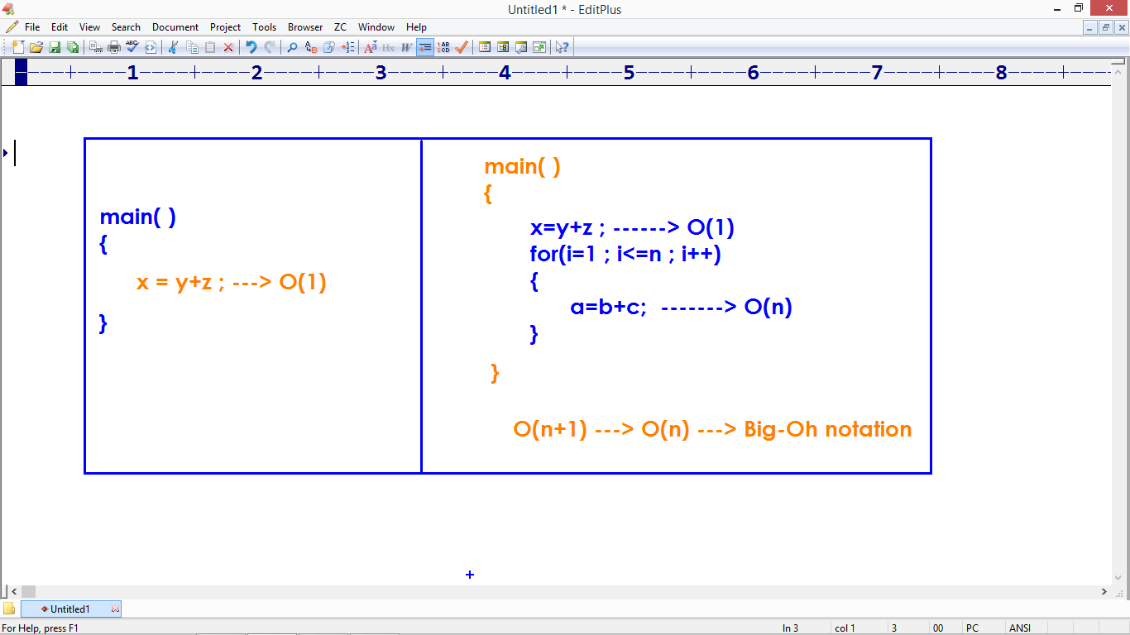

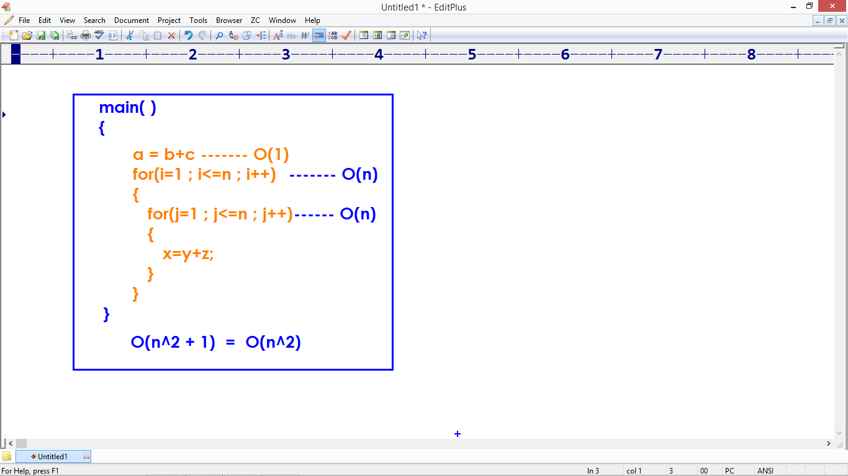

* The Statements also negligible.
* Only operations will be counted.
* n^2 + n + 1 ---> O(n)

**Expression:**

an^2 + bn + c

**With values:**

100n^2 + 50n + 1

**Time complexity is :**

100n^2 ---> Big Oh notation

